- Authentication Method Management:
  - Lab Scenario: Simulate an account takeover by trying to register a new authentication method to a user account, then show how you can detect this activity in the Entra ID audit logs.
  - Skills Demonstrated: You can manage and secure authentication methods, a critical part of preventing phishing and credential theft.

Phase 1: Preparation (The Target Account)
You need a standard test user account that the simulated attacker will compromise.
- Create a Test User:
  - Go to the Microsoft Entra admin center.
  - Navigate to Identity > Users > All users.
  - Create a new user (e.g., TestUser@yourdomain.com) and set a simple password.
- Enable MFA/Registration:
  - Ensure the test user is enabled for multi-factor authentication (MFA) registration. This is typically the default in modern tenants, or it might be enforced via a Conditional Access policy.
Conditional access policy is enabled as seen in screen shot below

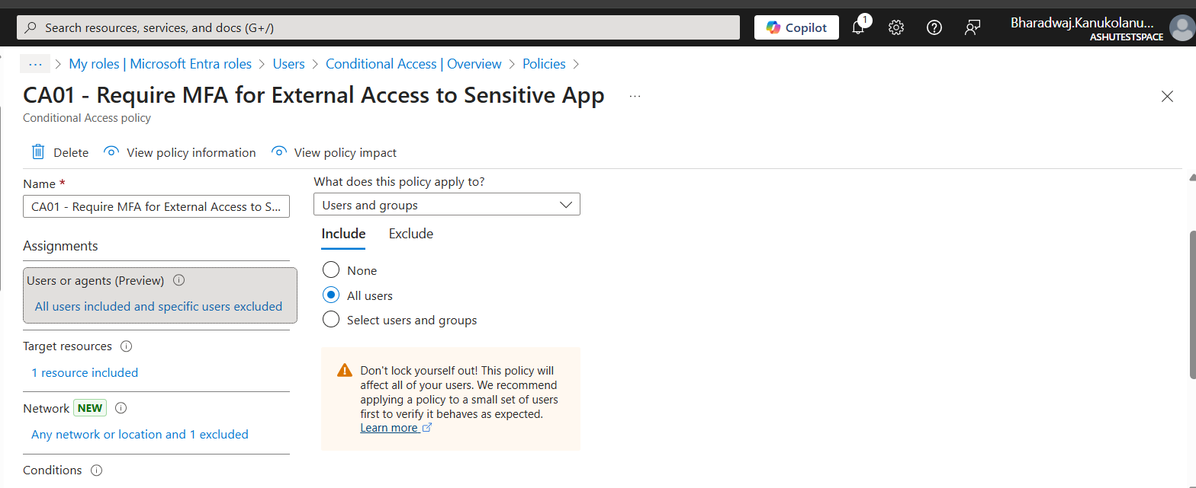
Phase 2: Simulation (The Account Takeover Attempt)
This phase simulates the attacker successfully obtaining the user's password and adding their own secondary authentication method.
- Open a Private/Incognito Browser: This ensures you are not logged in with your administrator account.
- Navigate to the Security Info Page: Go to the security registration portal:
  - https://myaccount.microsoft.com/security-info
- Log in as the Test User: Use the username and password of the test account you created in Phase 1.
- Register a New Method (The Simulation):
  - The system may prompt you to register a method if one hasn't been set up yet. If one already exists, click + Add sign-in method.
  - Select a method you can control, such as Phone (by entering your own phone number) or Microsoft Authenticator (by setting it up on your device).
  - Crucially, complete the registration process. The prompt will say something like, "Success! Your [Method] is now registered."
- Log Out: Sign out of the test user's session.

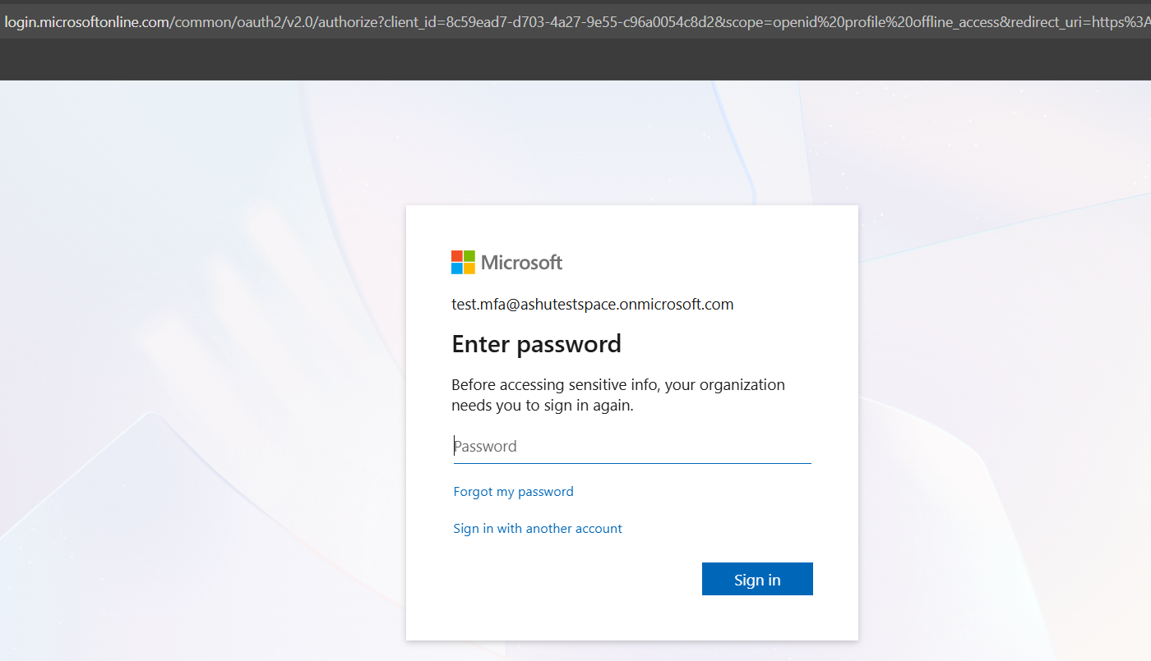
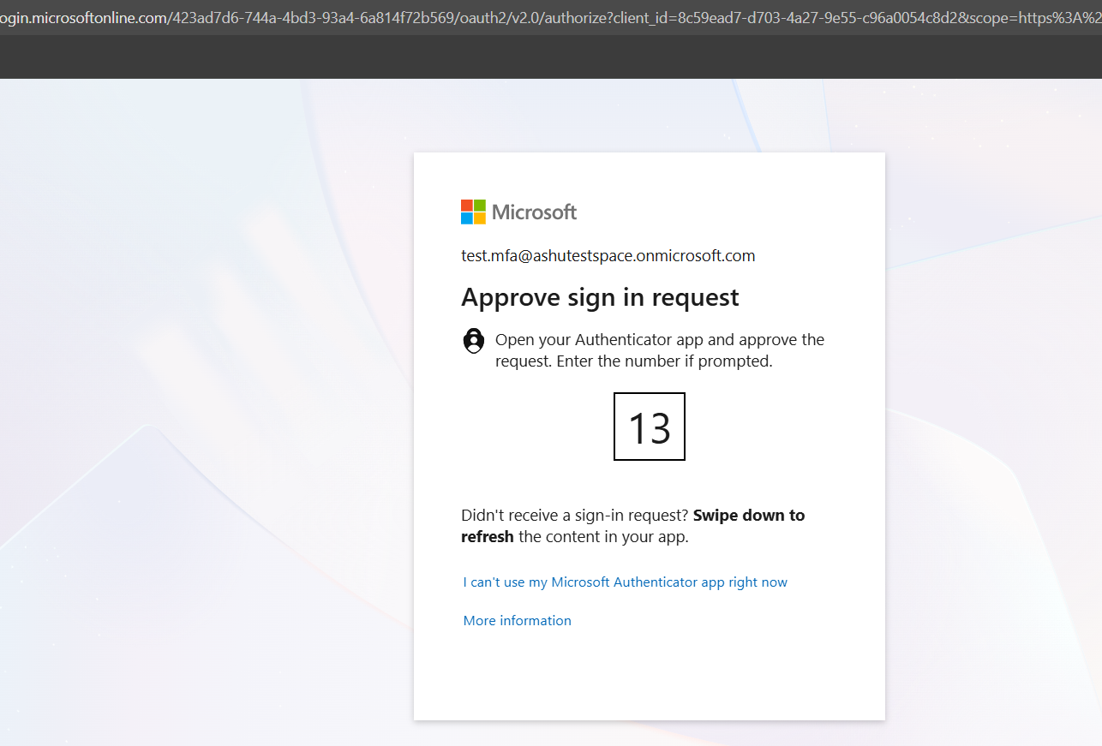
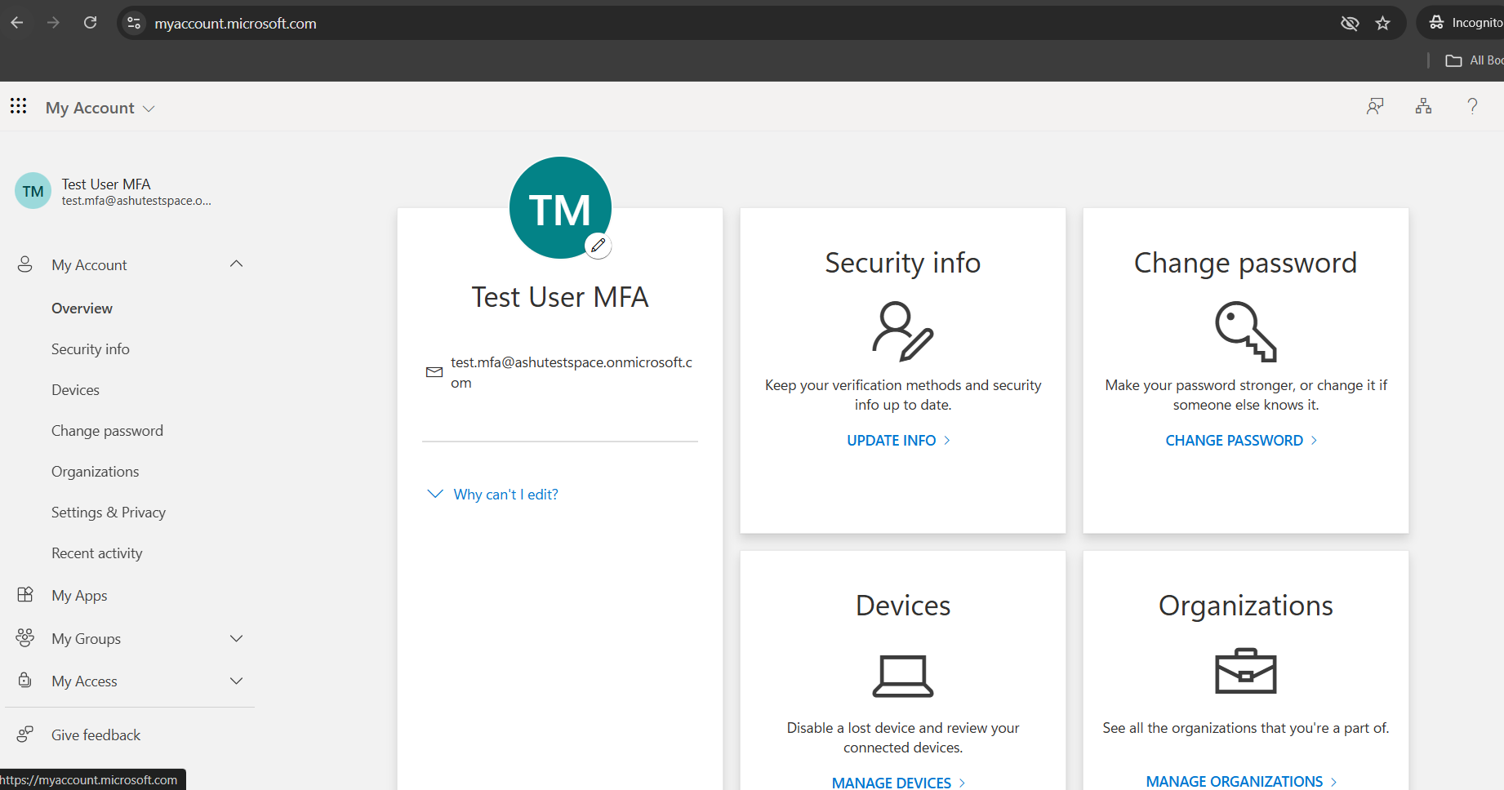
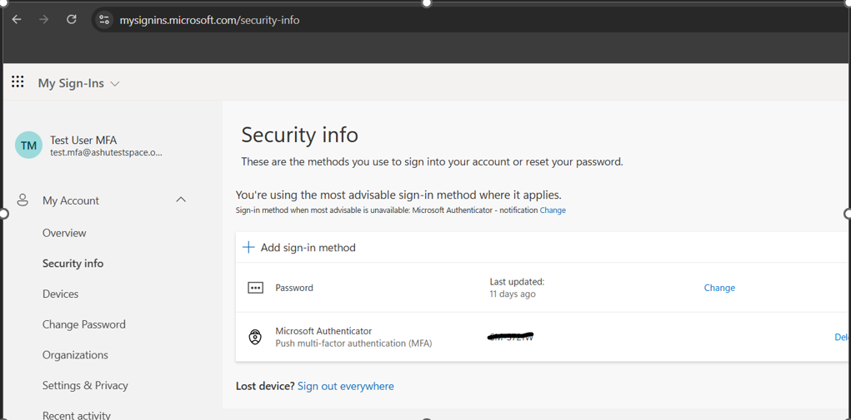
Click on add sign in method
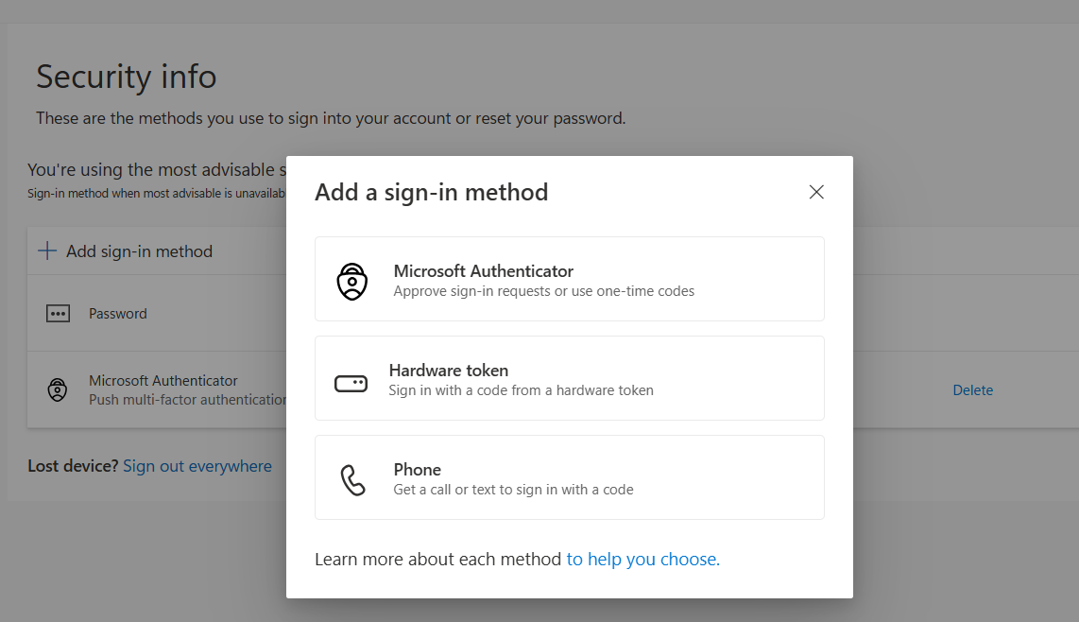
Since I am already using an existing user who has mfa enabled, I shall now sign up for sign in method as phone.
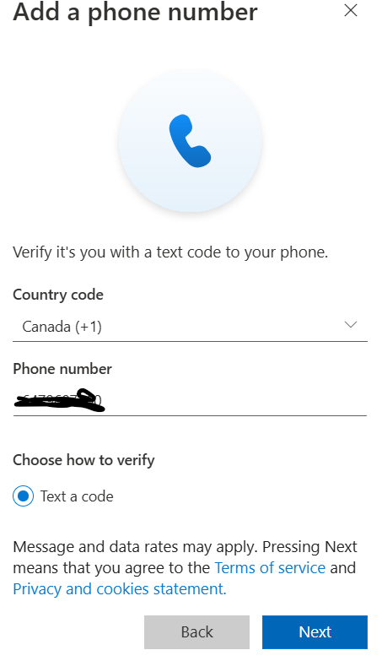

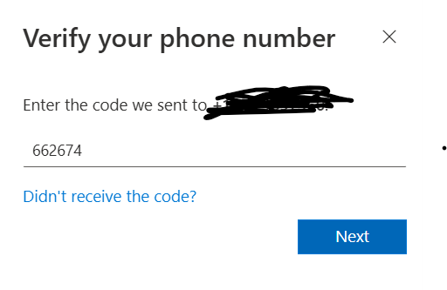
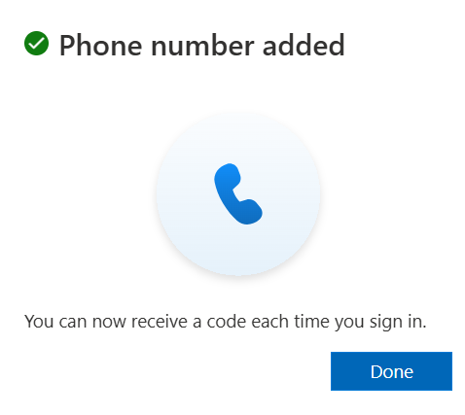
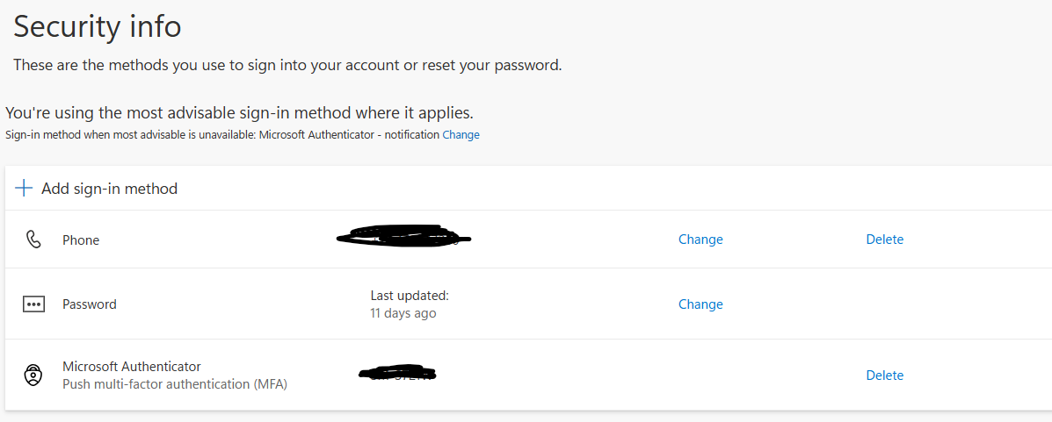
Phase 3: Detection (Auditing the Activity)
This phase involves switching back to your administrator role and using the audit logs to find evidence of the unauthorized change.
- Log in as Administrator: Return to your standard browser and log into the Microsoft Entra admin center.
- Navigate to Audit Logs:
  - Go to Identity > Monitoring & health > Audit logs.
- Filter the Logs: Use the filtering options to quickly isolate the suspicious event:
  - Date: Set the time range to the last hour or the specific time window when you performed Phase 2.
  - Service: Select User Management. (Authentication method changes often fall under this service category).
  - Activity: Type and select Add authentication method.
- Analyze the Result:
  - You should see one or more records. Click on the relevant record where the Initiated by user is your TestUser.
  - In the Activity details, look for:
    - Targeted resource: The user account that was modified.
    - Modified properties: This will often show the specific method that was added, for example, StrongAuthenticationMethods changed from [] to [{methodType: MobilePhone, status: 1, ...}].
- Identify the Threat: The presence of the Add authentication method activity, coupled with the TestUser being the initiator (which is correct, as the attacker logged in as the user), confirms that a security setting was successfully changed. A real-world investigation would then need to correlate the IP Address and Location from the log to determine if it was a suspicious logon.
